**Setting Up CloudWatch Alarms for AWS Monitoring**

Effortlessly Monitor and Manage Your AWS Resources with CloudWatch Alarm

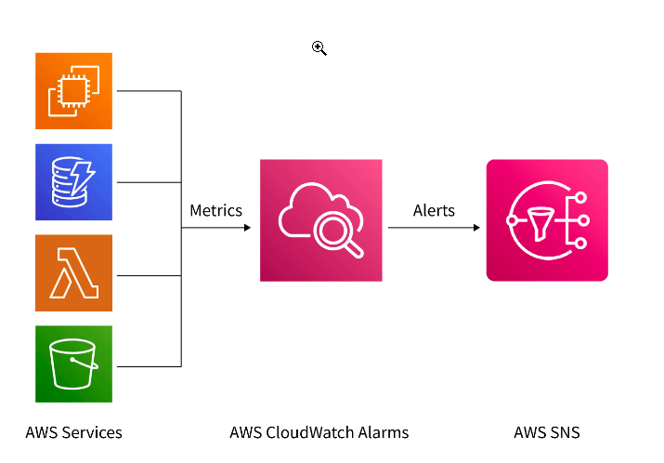

**Introduction:**

In the dynamic landscape of cloud computing, effective monitoring is paramount to ensure the optimal performance and reliability of AWS resources. AWS CloudWatch provides a robust solution for monitoring various metrics, and setting up alarms is a key component of this process. This guide will walk you through the step-by-step process of configuring CloudWatch alarms, empowering you to proactively manage your AWS infrastructure.

**Prerequisites:**

1. An active AWS Account with management console access.

**Creating CloudWatch Alarms:**

1. Access the AWS Management Console:

* Open your web browser and navigate to [AWS Management Console](https://aws.amazon.com/).
* Log in to your AWS account.

2. Go to CloudWatch:

* In the AWS Management Console, locate and click on “Services” in the top left corner.
* Under “Management & Governance,” select “CloudWatch.”

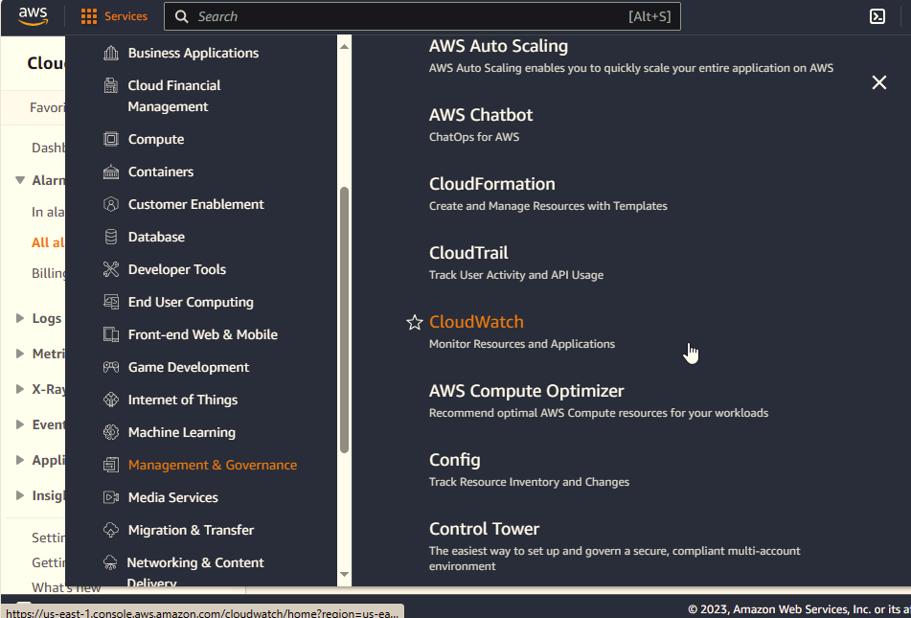

3. Navigate to Alarms:

* In the CloudWatch dashboard, find the left-hand navigation pane.
* Click on “Alarms” under the “All arms” section.
* On the “All alarms” page, click the “Create Alarm” button.

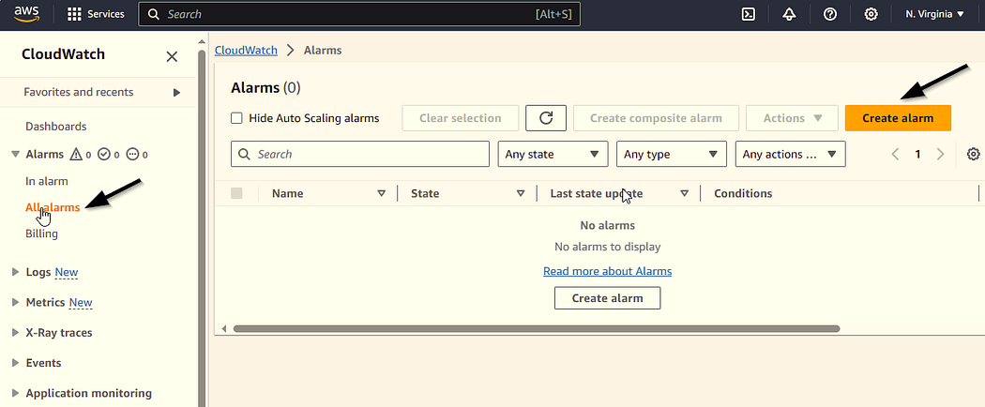

4. Select Metric:

* Choose the metric you want to monitor by selecting a data source (e.g., EC2, RDS) or a custom metric.

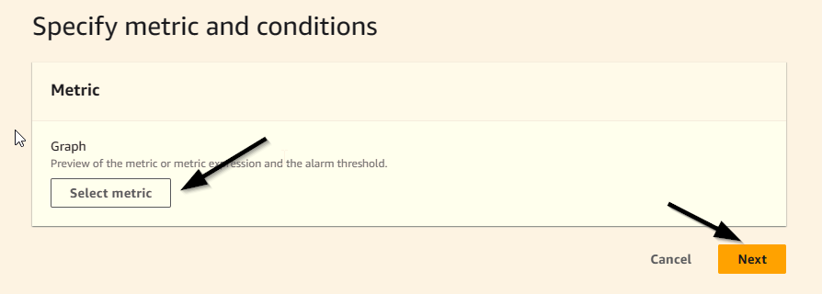

* Here we can select our ec2 prefered condions
* Here we selecting “cpu utalization”
* And click “select metric”

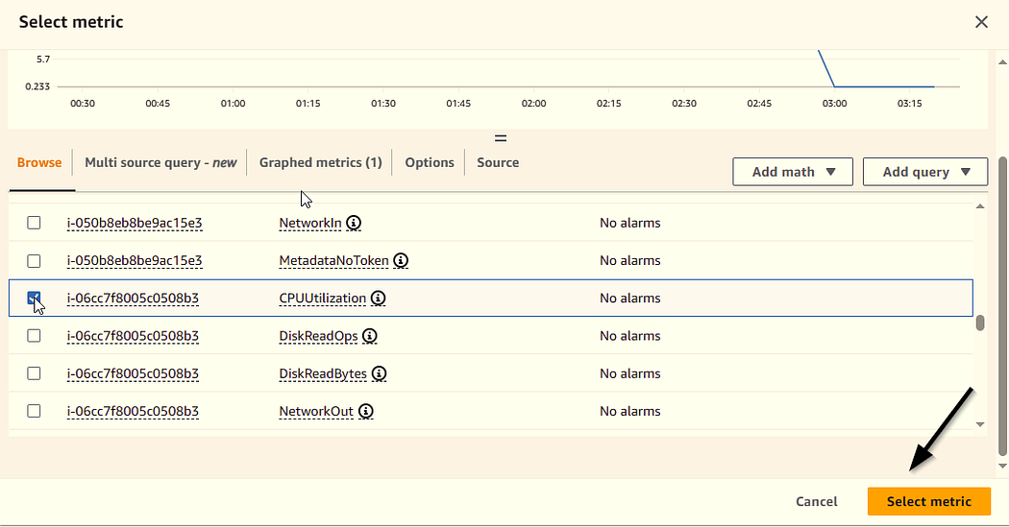

5. Define Conditions:

* Set conditions for the alarm. Specify thresholds, comparison operators, and evaluation periods.
* we can set conditions what is our requirments

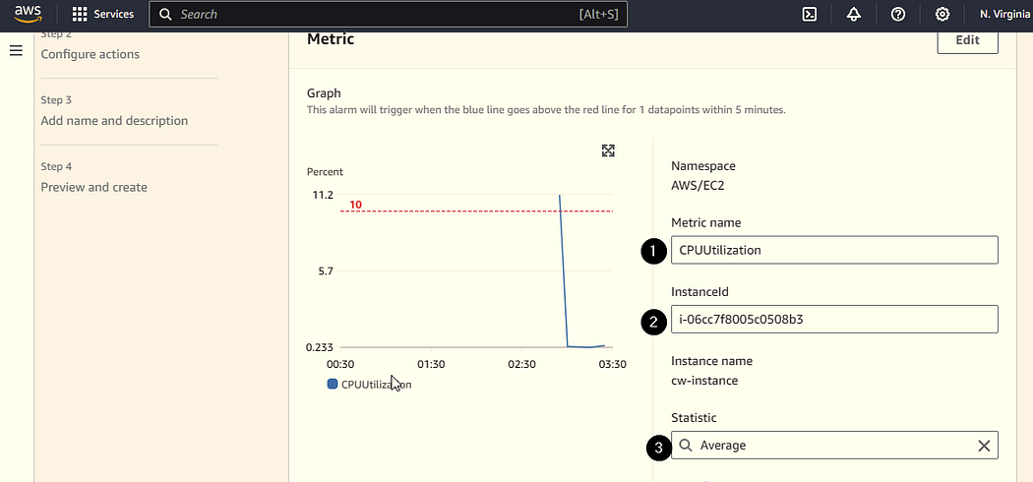

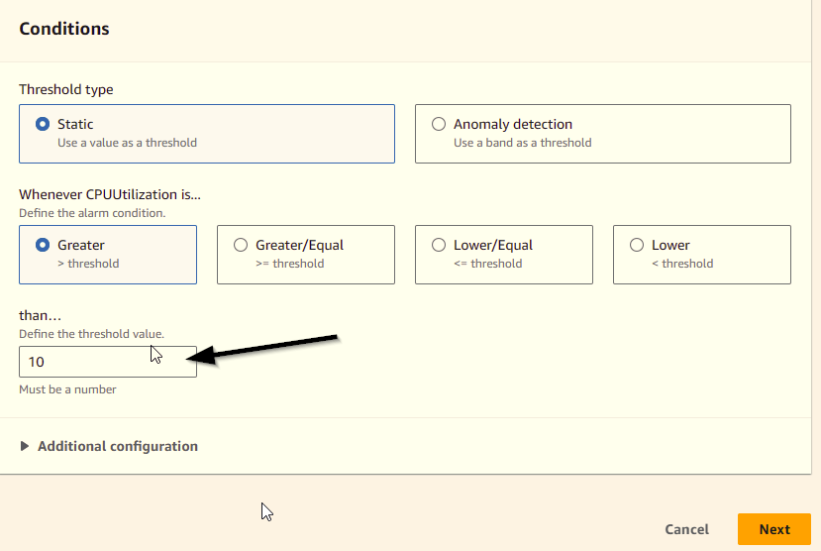

* In the define threshold value section we can make diffrent value what our own requirment
* Click next to continue

6. Set Actions on configure SNS topic

* Choose “Create a new SNS topic.”
* Enter a name for the new SNS topic.
* Enter E-mail as a end point
* click create topic

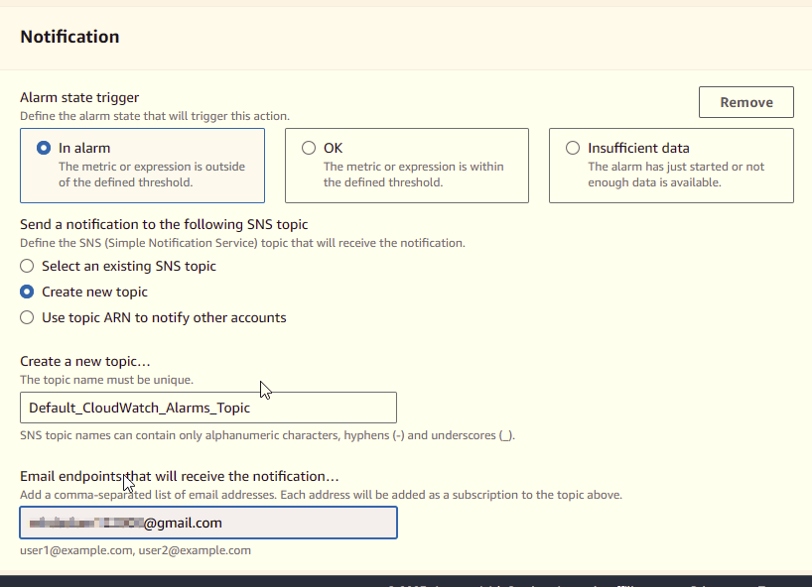

* After creating sns topic aws recive you a conformation mail in you gmail adress give

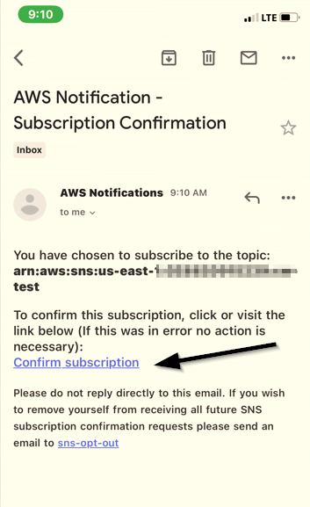

* Click the confirm subscription

1. Add Name and Description:
2. Provide a meaningful name and description for your alarm to easily identify its purpose.

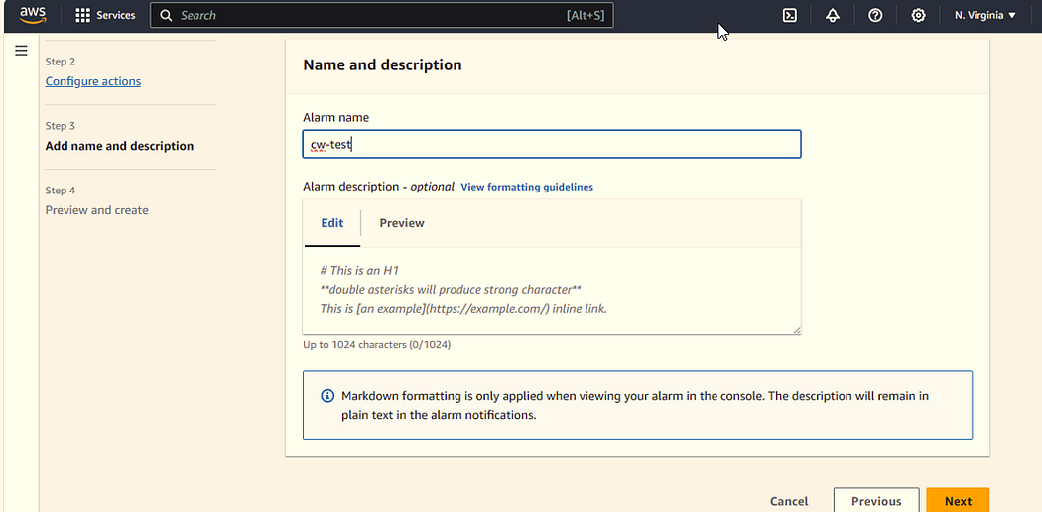

1. Review and Create:

* Review your configuration to ensure it meets your requirements.

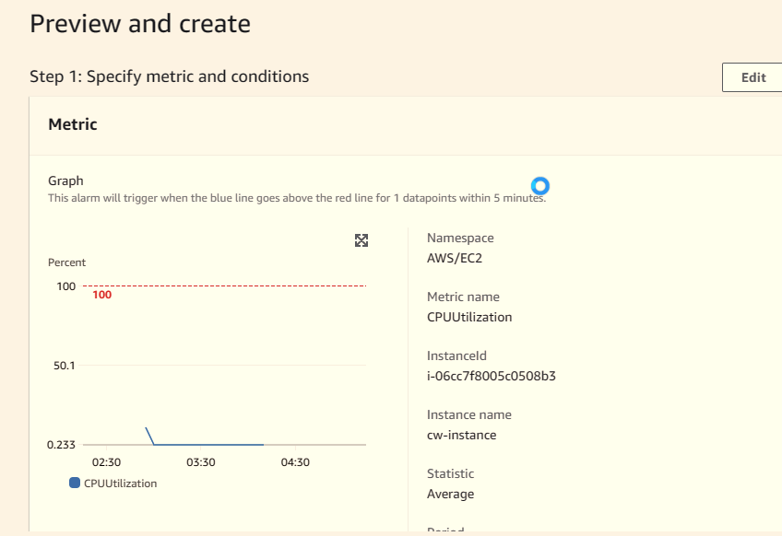

* Here we can review the conditions what we give

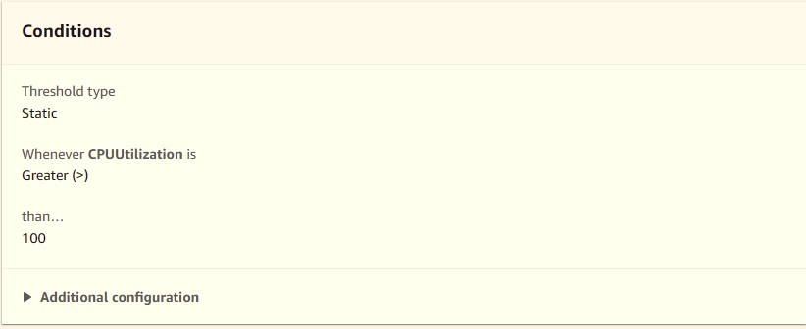

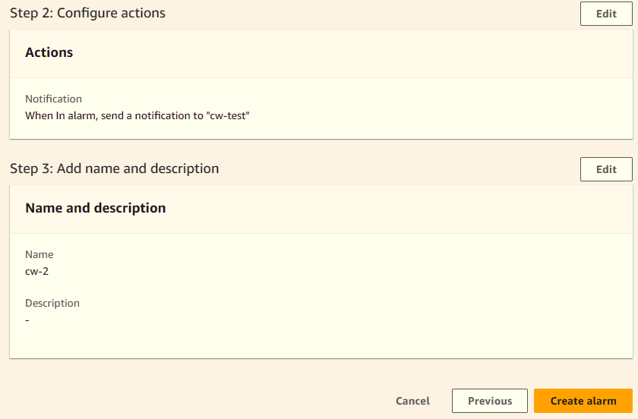

* Click “Create Alarm” to finalize the alarm setup.
* If the cpu utilization become morethan what we give the value we get an massage to our required mail adress

**Conclusion:**

Configuring CloudWatch alarms provides a proactive approach to managing and monitoring your AWS environment. By establishing customized metrics, defining thresholds, and setting up alarm notifications, you gain real-time insights into your resources’ behavior.